COVID-19 RETURN TO WORK INDUCTION MANUAL
NAME OF BUSINESS

COVID-19 WORKPLACE INDUCTION

To reduce the impact of COVID-19 outbreak conditions in our business, and to reduce the risk of infection we have prepared the workplace for COVID-19.

The purpose of this manual is to inform you of the steps taken and ensure that you know and understand the policies, procedures and practices that must be followed.

EVERY STAFF MEMBER MUST READ THROUGH THIS MANUAL AND BE PROPERLY TRAINED ON THEIR RESPONSIBILITIES IN TERMS OF WORKPLACE SAFETY

This manual is designed as a supplement to the COVID-19 policies, procedures and practices manual. It should not be considered a stand-alone document. For the most recent information relating to the company’s COVID-19 strategy, always refer to the latest updated COVID-19 policies, procedures and practices manual

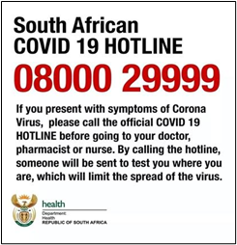

WHAT IS COVID-19?

COVID-19 is a respiratory disease caused by the SARS-CoV-2 virus. It is an infectious disease that is spread, directly or indirectly, from one person to another. It is a pandemic, which means that it occurs all over the world.

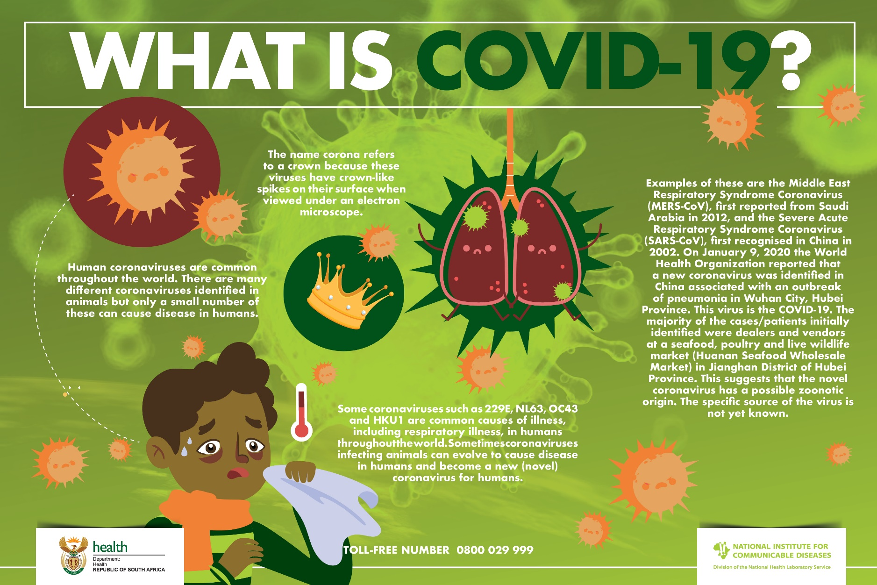
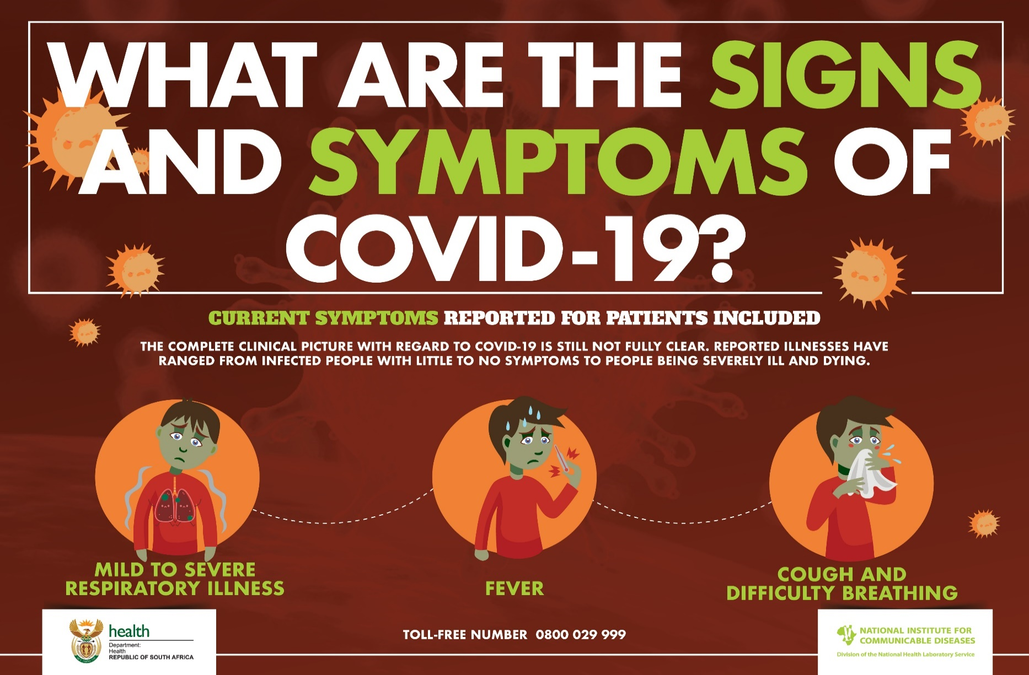

SIGNS AND SYMPTOMS OF COVID-19
Infection can cause mild to severe illness and, in some cases, can be fatal. Symptoms typically include:
- fever
- cough
- shortness of breath and breathing difficulties

In more severe cases, infection can cause illnesses such as pneumonia, severe acute respiratory syndrome, kidney failure and even death, according to the World Health Organisation (WHO). Other people, referred to as asymptomatic cases, have experienced no symptoms at all.

SYMPTOMS OF COVID-19 CAN APPEAR 2 TO 14 DAYS AFTER EXPOSURE.
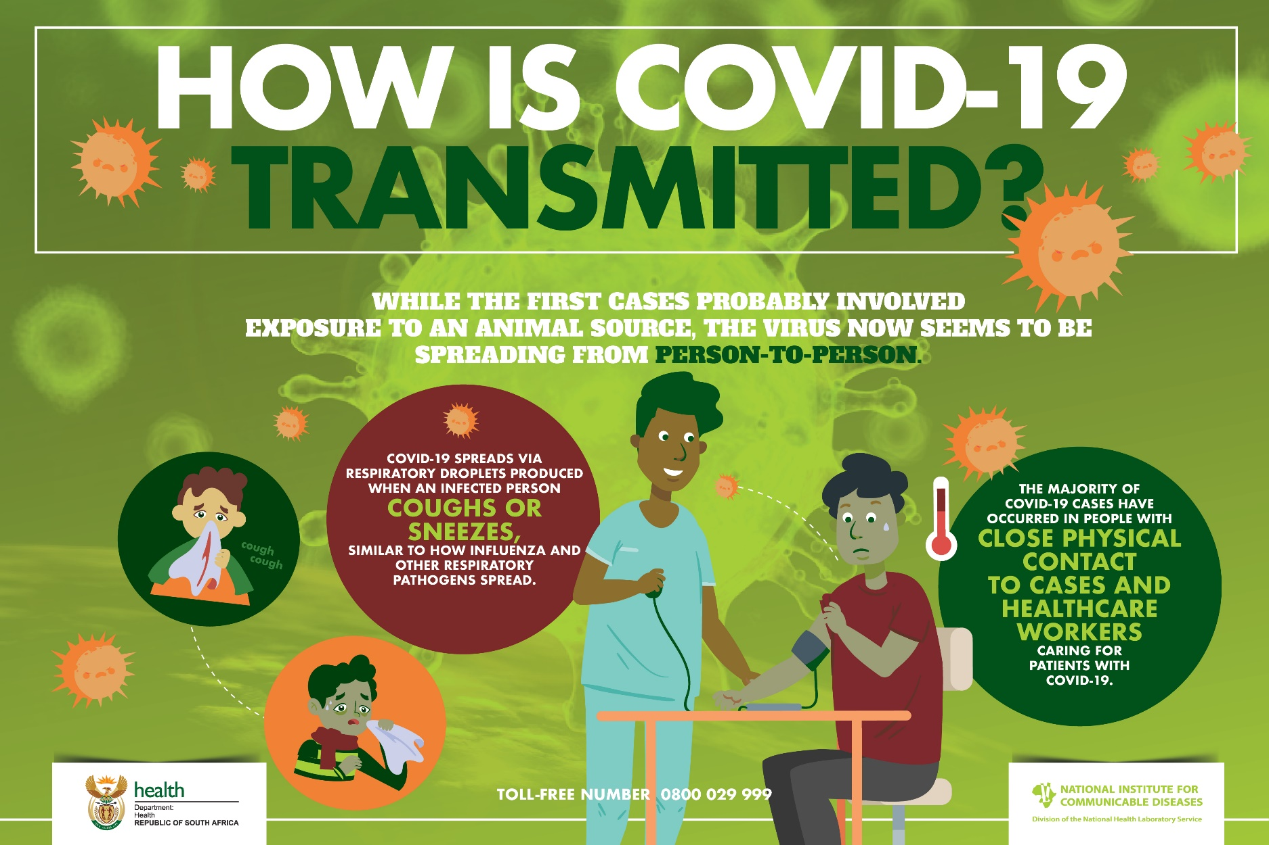

HOW IS COVID-19 SPREAD?

The virus is thought to spread mainly from person-to-person, including:

- Between people who are in close contact with one another (within 1 metre)

- Through respiratory droplets produced when an infected person coughs or sneezes. People are thought to be most contagious when they are most symptomatic (i.e., experiencing fever, cough, and/or shortness of breath)

- By touching a surface or object that has SARS-CoV-2 on it and then touching your own mouth, nose, or possibly their eyes, but this is not thought to be the primary way the virus spreads.
The virus can survive for different periods, dependent on:

• what surface the virus is on
• whether it is exposed to sunlight
• differences in temperature and humidity
• exposure to cleaning products

Under most circumstances, the amount of infectious virus on any contaminated surfaces is likely to decrease significantly over 72 hours.

Regular hand hygiene and cleaning of frequently touched surfaces may help to reduce the risk of infection.

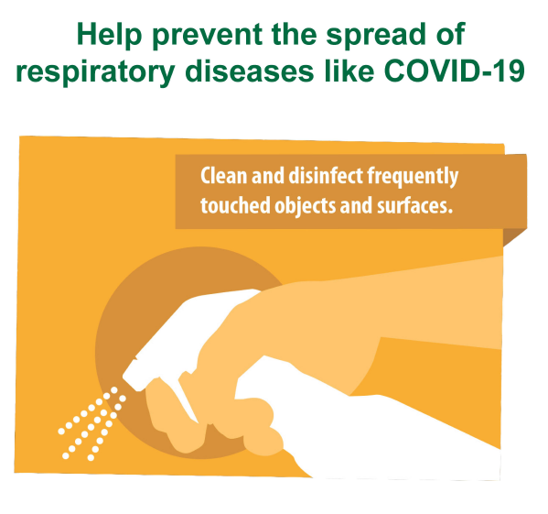

WHO IS AT RISK?

Everyone is at risk of contracting the virus. If you contract the virus, your symptoms may vary between nothing at all (you won’t know you are sick) to very ill. Certain people are more at risk of developing complications and becoming very ill.

These include:

- People with severe obesity (body mass index [BMI] of 40 or higher)

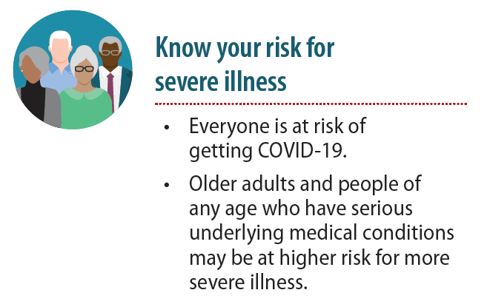
- People with diabetes

- Older adults (65 years +)

- People with chronic lung disease or moderate to severe asthma

- People who have serious heart conditions

- People with chronic kidney disease undergoing dialysis

- People with liver disease

- People who are “immunocompromised” (have a weak immune system). Many conditions can cause a person to be immunocompromised, including cancer treatment, smoking, bone marrow or organ transplantation, immune deficiencies, poorly controlled HIV or AIDS, and prolonged use of cortico-steroids and other immune weakening medications

PEOPLE WHO ARE AT HIGHER RISK MUST TAKE EXTRA PRECAUTIONS TO AVOID EXPOSURE.

PREVENTING SPREAD OF INFECTION

There is currently no vaccine to prevent COVID-19.

The best way to prevent infection is to avoid being exposed to the virus. Prevention measures described below must be taken now, even if COVID-19 countermeasures are not in place in your community.

We all share the responsibility for health and safety in the workplace.

For this reason, we must all pro-actively identify dangers and develop control measures to make the workplace safe. It is very important that you abide by any policies and procedures adopted to stop the spread of the Corona Virus. It is also important for you to inform your employer if you become aware of any risk to the health of yourself and your colleagues.

HOW A COVID-19 OUTBREAK COULD AFFECT THE WORKPLACE

In the absence of a vaccine, we may see an outbreak infecting a great number of persons for an extended period. As a result we may experience:

- Absenteeism. Employees could be absent because they are sick; are caregivers for sick family members; are caregivers for children if schools or day care centers are closed; have at-risk people at home, such as immuno-compromised family members; or are afraid to come to work because of fear of possible exposure.

- Change in patterns of commerce. Clients may change the way they do business, be scared to come to the business and change how they want to meet or do business.

- Interrupted supply/delivery. Delivery of items may be delayed or cancelled with or without notification, so it is important to ensure there is enough time to top up on any supplies in case of delays.

COVID-19 SYMPTOMS AT HOME
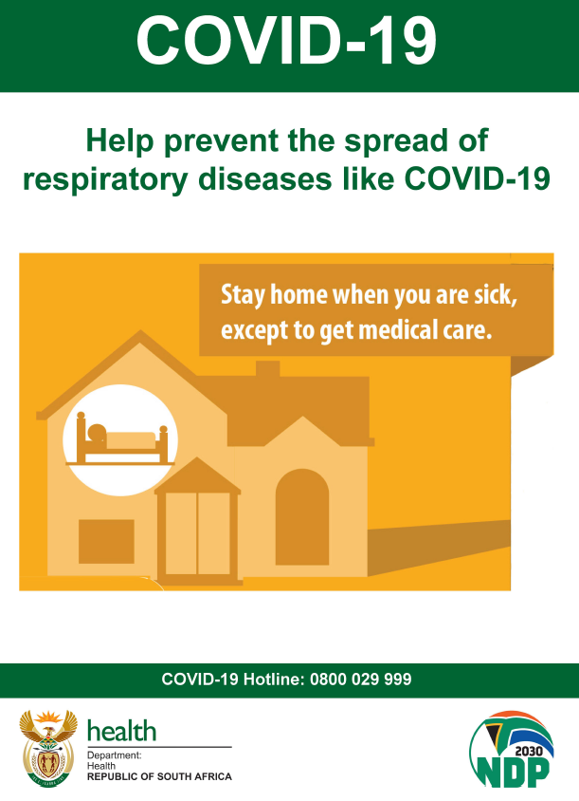
It is very important that you do not come to work if you show symptoms of COVID-19. If this happens, contact your manager immediately to let them know.

People who contract COVID-19 may take anywhere from one to 14 days to develop symptoms. You must inform your healthcare provider if you present with symptoms of COVID-19. The Hotline for the COVID-19 as per the Department of Health website: 0800 029 999
Anyone with COVID‐19-like symptoms such as a sore throat, fever, sneezing, or coughing must self‐isolate at home for a minimum of 14 days from when the symptoms start and keep screening. You will be placed on sick leave for this period.
If you show symptoms of acute respiratory illness you must seek medical treatment and diagnosis as soon as possible.
If your symptoms clear after 14 days and there is no further concern, you may return to work but will be monitored.
If your symptoms do not clear up, or get worse, or if you want to return to work sooner, you should go to the closest testing centre for testing.
If you have acute respiratory illness symptoms you must stay home until you are cleared for work by a registered medical practitioner. To qualify for sick leave, a valid medical certificate is required.
Keep your manager informed. Based on the outcome of the test, you may either return to work or follow the directions of the Health official.
No person may return to work until their symptoms are completely resolved.

IF YOU HAVE BEEN IN CONTACT WITH AN INFECTED PERSON WHILE AT HOME
If you have been in close contact (within 1 meter) with someone who has since been diagnosed with COVID-19, you must immediately inform the Department of Health. If, after informing the Department of Health, you are required to self-quarantine, then the following applies:
- If you are able to work from home during this period and it is possible in terms of your position, then there is no requirement to submit a sick leave or annual leave request. You are, however, required to report daily to your line manager.
- If you become sick during this period, the normal sick leave policy will apply.

COMING TO WORK

Work permit

You will be issued with a work permit, which you must carry with you when travelling to or from work. You must also carry your ID with you at all times

Travel

Travel between provinces, metropolitan areas and districts is allowed for workers who have to commute to work daily. Keep your work permit with you at all times if you have to travel for work.

You must comply with instructions from local authorities if you are travelling. If, for example, you are told by local authorities not to go somewhere, you must comply with this.

Do not travel if you are not feeling well with any COVID-19 symptom. If you feel ill, or experience any COVID-19 symptoms while travelling, immediately return home and contact your manager. The proper procedure must then be followed.

Public transport

Where possible, travel alone in your vehicle in order to practice physical distancing. Where public transport is used, try to travel at off peak times where possible

All public transport operators must put measures in place to adhere to physical distancing to curb the spread of the virus. Physical distancing measures must be maintained during any trip.

All passengers and drivers must wear a face mask or an item covering his or her nose and mouth. No person will be allowed to use any form of Public Transport if they do not wear a face mask or an item covering his or her nose and mouth.

Taxis and Buses

Try to keep a safe distance between yourself and anyone who may be coughing and sneezing. If possible, try to sit in the backseat. If possible, open the windows to improve ventilation.

Handle your own belongings at all stages of the trip.

All operators must ensure that public transport vehicles are sanitized before each toad journey and after dropping of passenger. Operators must ensure that all public transport vehicles' doors and window handles, arm rest and handrails are sanitized after every load and passengers be sanitised before they enter the vehicle. Check that operators are complying with these requirements.

Wash your hands with soap and water for at least 20 seconds or sanitise hands with alcohol-based hand sanitiser before and after travelling on public transport.

Carry sanitiser with you to ensure this happens.

UBER:

Passengers must wear a cloth mask or face covering. Driver-partners are required to wear a cloth mask and sanitise the vehicle before every trip.

Limitations on passengers:

- UberGo, UberX, UberBLACK, UberASSIST, UberVIP:Maximum 2 passengers
- UberXL: Maximum 3 passengers
- UberVan: Maximum 4 passengers

Staff who return from travelling to high risk areas

If you return from a high-risk area where COVID-19 is spreading, and may have been compromised, you must monitor yourself for symptoms for 14 days. Where any symptoms are experienced, the procedure for staff who experiencing any COVID-19 symptoms procedure must be followed.

Company transport

The number of workers being transported at any one given time will be assessed and measures will be employed to ensure distance between workers is maintained. If it is not possible to ensure 2 metres of distance between workers in a vehicle through these measures, other control measures, such as personal protective equipment (PPE) will be used.

Where multiple staff are transported, measures taken includes:

- Hand-washing facilities or sanitising stations are available to workers as they enter and exit the vehicle. Staff must sanitise their hands before entering and after exiting the vehicle
- All staff must wear facemasks
- Staff must sit one to a seat, with riders staggered to allow maximum distance
- Staff numbers will be adjusted to minimise these per trip
- Larger vehicles will be used to ensure maximum spacing
- Multiple vehicles will be used
- High-contact surfaces within the vehicle(s) will be routinely properly cleaned. These include seatbelts, head rests, door handles, steering wheels, and hand holds.
- Where a suspected COVID-19 case is transported in the vehicle, the vehicle will be cleaned and sanitised

Company vehicles

The following procedures will reduce the risk of COVID-19 infection:

- Hand-washing facilities or sanitising stations are available to workers as they enter and exit the vehicle. Staff must sanitise their hands before entering and after exiting the vehicle
- Staff who travel will be issued with small bottles (50 - 100 ml) of alcohol-based hand sanitiser This can facilitate regular hand-washing.
- All staff must wear facemasks
- No passengers are permitted, unless authorised
- Where passengers are permitted in company vehicles, they must wash or sanitise their hands before entering the vehicle, facemasks must be worn, and the person must sit at the back seat with all windows opened.
- High-contact surfaces within the vehicle(s) will be routinely properly cleaned. These include seatbelts, head rests, door handles, steering wheels, and hand holds.
- Where a suspected COVID-19 case is transported in the vehicle, the vehicle will be thoroughly cleaned and sanitised

Identifying and isolating potentially infectious individuals is a critical step in protecting everyone at the workplace.
By following these procedures you will help:
- Identify and diagnose workers at risk of COVID-19 infection at an early stage
- Refer these workers for appropriate treatment, care and timeous return to work
- Protect other unaffected workers, visitors, customers and the general public
Every person who comes into the workplace must be wearing their mask. You will not be allowed in if you do not have your mask.
Every person coming into the workplace must sanitise their hands properly or wash them with soap and water for at least 20 seconds before being allowed in.
Every person who enters the workplace will be screened for COVID-19 related symptoms before being allowed to come in.
This means that you will be asked whether you have been in contact with a COVID-19 positive person, whether you experienced any COVID-19 symptoms, and whether you are feeling sick or not. The current criteria for the identification of persons under investigation (PUI) are:
- Cough
- sore throat
- shortness of breath or fever/chills
- ≥ 37.5°C measured temperature

You must also report any additional symptoms of:

• body aches
• loss of smell
• loss of taste
• nausea,
• vomiting
• diarrhoea
• fatigue
• weakness or tiredness
Any symptoms must be reported to management before you enter the workplace so that a decision can be made whether you can come in and any other action to be taken.
Your temperature will be taken and recorded in the register at the door. If it is 37.5°C or higher, you will not be allowed inside and will have to go home and self-quarantine or get yourself tested.

ANY CLIENT WHO HAS ANY COVID-19 SYMPTOMS OR A TEMPERATURE OF 37,5 C OR HIGHER WILL NOT BE ALLOWED TO ENTER THE PREMISES.
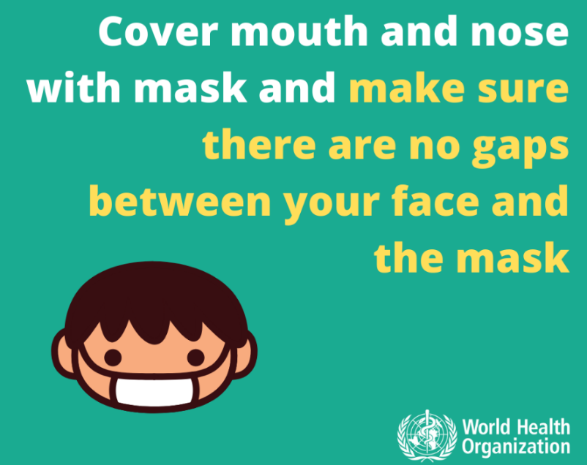

AT WORK

Physical contact

Physical contact between staff members such as handshakes or hugs is not allowed. Where physical contact is required in terms of the staff member’s function, this must be done under strict hygienic conditions, using the correct personal protective equipment.

Greet people without making any physical contact.

Procedure review

We have changed the following procedures to make sure that social distancing happens:

………………………….

Physical Distancing
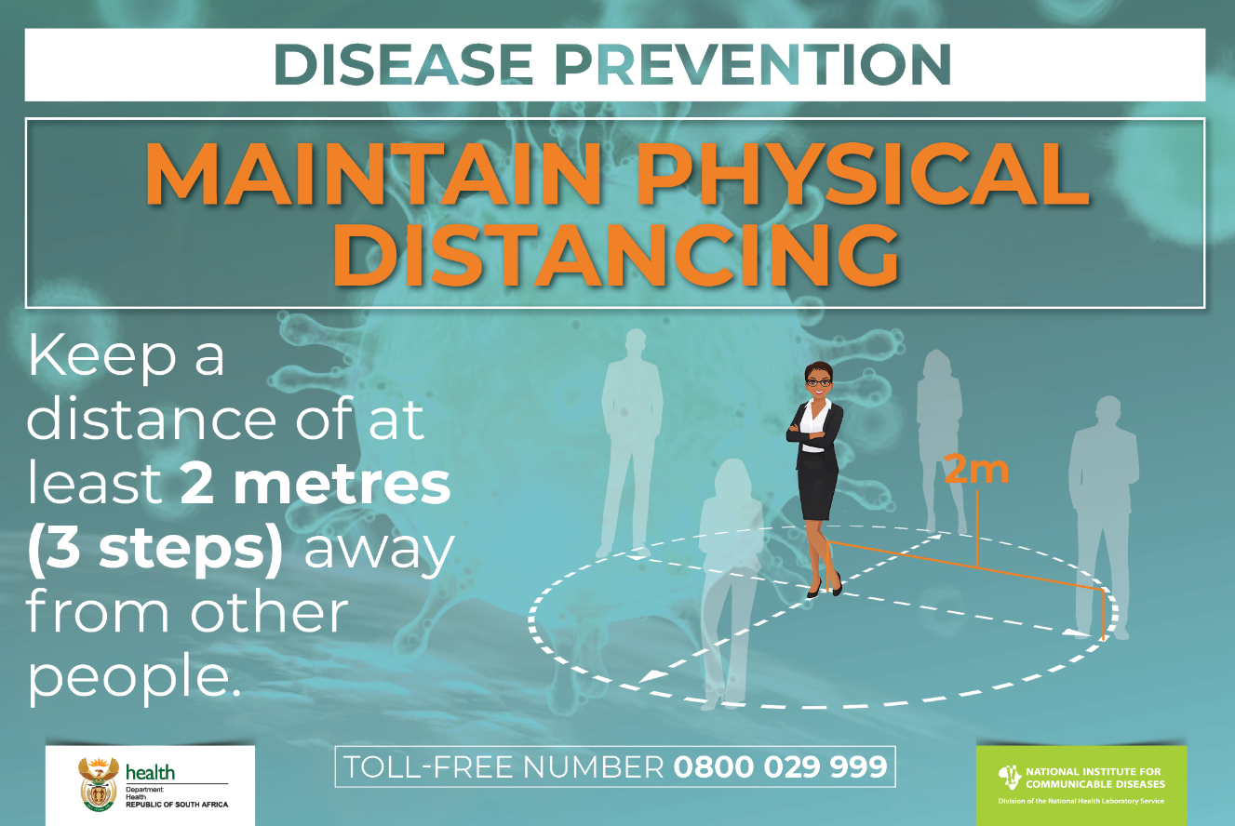

Your workplace is arranged to ensure that you keep a safe distance from everyone else. Make sure that you do not re-arrange or change anything, and that you keep your distance.
You must stay at least 1 ½ to 2 metres away from other people.

TRY TO REMAIN WITHIN THE PREMISES DURING WORK HOURS.

COMMON AREAS AND SHARED FACILITIES

The shared use of facilities, washrooms, kitchens etc. poses a risk of staff not maintaining social distancing, not wearing facemasks, and poor hygiene.

Common areas at the workspace have been identified and measures implemented to ensure social distancing is maintained.

Avoid any place where there is a form of crowding as far as possible.

SUPPORT OTHERS TO COMPLY WITH THE GOLDEN RULES.

This is controlled by:

- Breaktimes have been staggered to reduce the number of people in a common area
- Staff must not eat, drink or smoke in the workplace, but use designated areas
- Staff must wash their hands before and after eating, drinking or smoking
- Eating utensils must not be shared, and must be properly cleaned after use
- No alcohol may be sold, dispensed or distributed.

Clocking in area:

- Floor markings ensure the correct distance is kept
- No queueing is permitted
- Clocking in is done using a website application such as TimeStation
- Physical barriers are in place

Entrance:

- Staff are not permitted to congregate in the entrance area
- Customers are permitted access in a controlled manner and are immediately escorted to offices or meeting rooms

Locker areas:

- Locker areas will have restricted entrance over a staggered time period
- Floor markings ensure the correct distance is kept
- No queueing is permitted
- Lockers must be sanitised at least …….

Changerooms:

Meeting rooms:

Stairs:

A distance of 2 metres must be kept between persons on stairs.

Parking area:

Smoking area:

If you smoke, you must remember to keep your 1 ½ metre distance. You may not share cigarettes and if you borrow someone’s lighter or matches, sanitise your hands before and afterwards.

KITCHEN FACILITIES:

Kitchen facilities are high risk areas for contamination and must be properly cleaned and disinfected every …… …. hours.

Equipment must be sanitised before and after use.

Staff may not share eating utensils, and if this is not possible, utensils must be properly cleaned and sanitised between use.

Do not share food or drink

TOILETS AND WASHROOMS

Adequate toilets and washroom facilities are provided and properly maintained as required by the Health and Safety Act. Washroom facilities have adequate supplies of soap, water and toilet paper. These must be kept clean, properly stocked and in good working order.

Toilets must be monitored as part of physical distancing enforcement. There will be limited access to toilet facilities to make sure that there is proper distancing. This will be controlled by:

Place a sign on the main door indicating when one of the toilets is in use to ensure that only one person at a time enters.
Occupancy limits will be posted

Toilets are high risk areas for contamination and must be properly cleaned and disinfected every …… …. hours.

No material towels are allowed for use to dry hands after washing. Only paper, or disposable towels or handblowers are allowed.

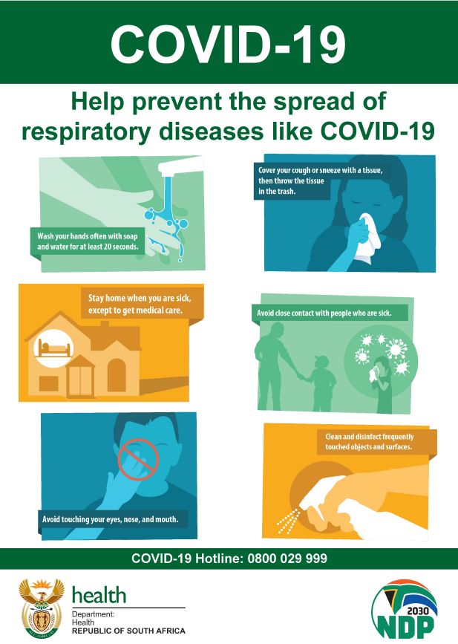

SHARING OF EQUIPMENT, STATIONERY AND WORK TOOLS

You must not use or share other workers’ facemasks, phones, stationery, or other work tools and equipment, and avoid sharing offices or desks when possible.

Where offices or desks have to be shared, they must be regularly cleaned and sanitised.

MEETINGS AND TRAINING

Face-to-face contact must be replaced with virtual communications, where possible

There is a risk that people attending a meeting might bring the COVID-19 virus to the meeting.

The following measures have been implemented to make sure that there is a safe distance between everyone at meetings:

…………………………………………….

Where a meeting can be held using technology, then a face-to-face meeting will not be held.

Only persons who have to be at the meeting must attend.

Anyone not feeling well must not attend any meeting.

Every person must provide contact details: mobile telephone number, email and address where they are staying. Details will be shared with local public health authorities and the rest of the attendees if anyone becomes ill with a suspected infectious disease. The names and contact details will be kept for at least one month. This will assist health care authorities to trace who have been exposed to the virus if anyone becomes ill shortly after the meeting.

Ensure that all participants in the meeting wash their hands for at least 20 seconds, or properly sanitise their hands before the meeting. Make sure there is enough hand sanitiser and tissues

Seats or meeting room layouts must be arranged so that everyone stays at least one and a half meters apart.

Where possible, open doors and windows.

Keep meetings as short as possible.

Anyone who coughs or sneezes must cover their face with the bend of their elbow or a tissue if they cough or sneeze.

Where someone in the meeting shows symptoms of COVID-19 or becomes ill, the procedure on how to deal with persons showing symptoms of COVID-19 must be followed.

If someone at the meeting or event is isolated as a suspected COVID-19 case, everyone who was at the meeting must be notified to monitor themselves for symptoms for 14 days and take additional precautions in respect of social distancing and hand hygiene.

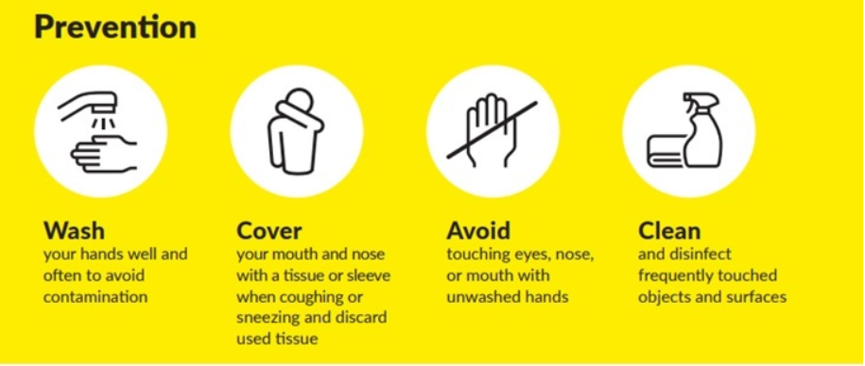

CLIENT MEETINGS

Physical distance measures (e.g. partitions, desk spacing) ensure that persons stay at least 1 ½ meters apart. The following measures have been implemented:

…………………………………………….

All clients will be screened at the door before coming in and will be told in advance that if they have any symptoms or feel unwell, they must not come in but should go home.

You and your client must wear a facemask at all times.

Seats must be arranged so that your client is at least one and a half meters away from you, unless there is a barrier between you.

Where possible, doors and windows must be opened to make sure the venue is well ventilated, but keep it safe!

Meetings must be kept as short as possible.

Sanitise your hands and ask your client to regularly sanitise theirs, especially before and after working with personal items like an ID book or bank card.

Cover your face with the bend of your elbow or a tissue if you cough or sneeze and dispose of used tissues safely in closed bins.

Where someone shows symptoms of COVID-19 or becomes ill, the procedure on how to deal with persons showing symptoms of COVID-19 must be followed.

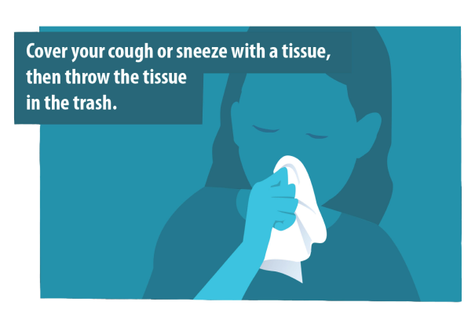

SYMPTOM SCREENING
You must check yourself for any symptoms at work and immediately notify your manager if you experience a:
- Cough
- sore throat
- shortness of breath or fever/chills

You must also report any additional symptoms of:

- body aches
- loss of smell
- loss of taste
- nausea,
- vomiting
- diarrhoea
- fatigue
- weakness or tiredness
Your temperature will be taken regularly and if it is 37.5 degrees or higher, you will immediately be moved to an isolated room/ area, being ……………………. for a second measurement.
If your second test measurement also reads higher than 37,5 degrees, and you have any other COVID-19 symptoms, you will be provided with a surgical mask and must go to be tested at the nearest centre.
If you only have a high temperature, you will be given a surgical mask and you must go home for self-quarantine.

CLEANING AND SANITISING

The workplace must be properly and regularly cleaned to remove the virus that causes COVID-19.

Workspaces must be kept clean and hygienic at all times. All work surfaces and equipment must be disinfected before work begins, regularly during the working period and after work ends.

A routine cleaning procedure will be implemented to ensure this.

All areas including washrooms, shared offices, and workstations must be cleaned and disinfected regularly.

Special attention must be given to frequently touched surfaces (e.g. telephones, keyboards, handbag bottoms, tabletops, door handles, light switches, desks, toilets, taps, TV remotes, kitchen surfaces and cupboard handles). Frequently touched surfaces such as doors, handrails, windows and vending machines must be cleaned and disinfected frequently using appropriate detergent and disinfectant solutions.

Surfaces that workers and members of the public come into contact with must be routinely cleaned and disinfected. These will be cleaned and sanitised at least:

Surfaces and fittings must be cleaned immediately when visibly soiled or after any spillage. Areas, surfaces and fittings must be cleaned more frequently when used repeatedly by a number of people.

In a busy environment with many people entering a workplace each day, more frequent disinfection is required.

Surfaces that are frequently touched, e.g. toilet door handles, etc, should be cleaned with diluted bleach disinfectant (20 ml bleach per litre water) hourly, or less frequently depending on the circumstance.

The following areas have been identified as requiring cleaning and disinfection more regularly:

AREA | RESPONSIBLE | INTERVAL

Waste bins have been identified as posing a possible risk of contamination. To mitigate this:

- Waste bins will be lined with a plastic bag so that they can be emptied without contacting the contents.
- No touch bins will be used
- No person may touch any bin except for cleaning staff
- Waste bins will be emptied at least …………………

Cleaning after COVID-19 case

Procedures and safety measures are in place to sanitise and clean the workplace in the event of any person testing positive for COVID-19 at the workplace.

Cleaning PPE

Cleaning staff will be provided with the required equipment and tools and appropriate personal protective equipment (“PPE”) suitable for the task.

Training will be provided to all cleaning staff on when to use PPE, what PPE is necessary, how to properly don (put on), use, and doff (take off) PPE, and how to properly dispose of PPE. Cleaning staff must be trained on the hazards of the cleaning chemicals used in the workplace in accordance with Hazardous Chemical Substances Regulations.

Fatigue Management

The following measures will be taken to avoid excessive workload on cleaning staff:

- organising shifts to take account of cleaning and sanitation tasks.
- assigning additional staff to the tasks
- asking workers to leave their workspace tidy
- ensuring staff sanitise and clean their personal workplace
- providing disposable sanitiser wipes so that commonly used surfaces (for example, doorknobs, keyboards, remote controls, desks) can be wiped down by workers.

COUGHING AND SNEEZING ETIQUETTE

Always cover your nose and mouth with a disposable tissue or your sleeve when coughing or sneezing and dispose of these safely.

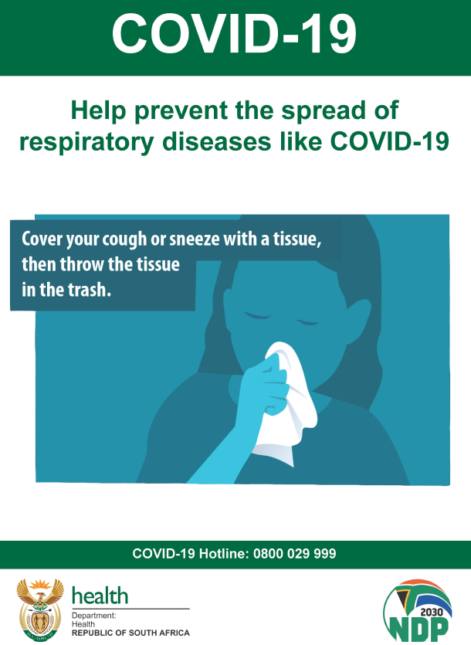

PERSONAL HYGIENE

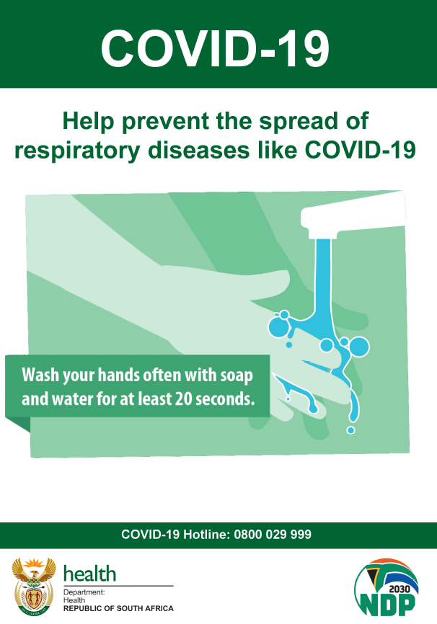

WASH YOUR BODY, HAIR (INCLUDING FACIAL HAIR) AND CLOTHES THOROUGHLY EVERY DAY.

Hand hygiene

Keeping your hands clean and sanitary is very important. You should regularly wash your hands or use hand sanitiser, especially when:

- Before and after using public transport
- Before and after using company transport or vehicles
- Before entering the workplace
- Regularly at the workplace
- Between each interaction with a member of the public
- Before putting on and after removing any PPE such as a facemask
- Before and after providing routine care for another person who needs assistance
- After contact with any frequently touched surface ( keyboards, screens, phones, door handles, work surfaces, cutlery and crockery etc.)
- After using a cellular phone
- After working with personal items such as a handbag
- Before and after using high touch items such as printers
- Before and after smoking
- After blowing one’s nose, coughing, or sneezing
- After using the restroom
- Before and after preparing or eating food
- After contact with animals or pets.
- Wash hands when they are visibly soiled

DO NOT TOUCH YOUR EYES, NOSE OR MOUTH, OR ANY OTHER PERSON WITH UNWASHED HANDS

How to properly wash your hands
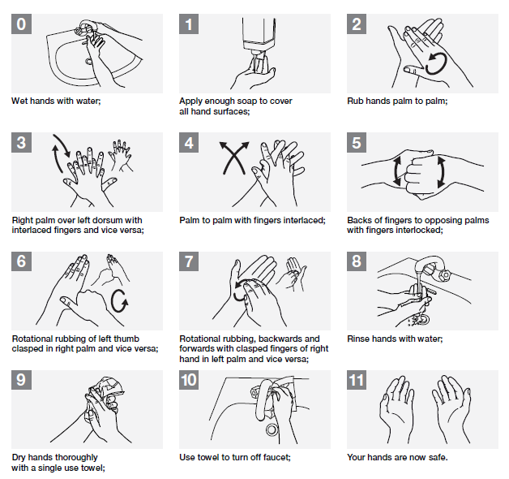
DO NOT USE ANY FABRIC TOWELLING TO DRY HANDS

Using hand sanitiser

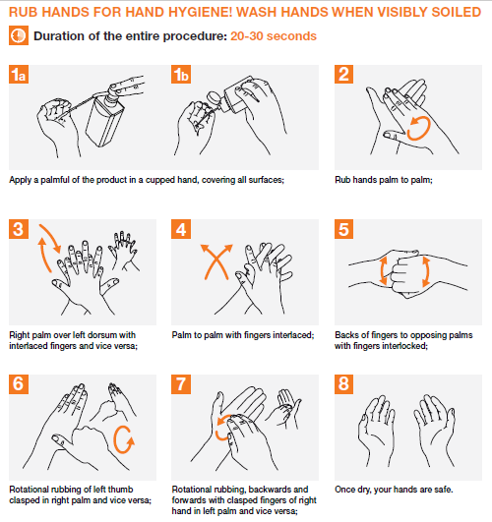

ONLY USED APPROVED 70% ALCOHOL BASED SANITISER

STAFF WHO ATTEND FUNERALS

Where interprovincial or inter-district travel is required to attend a funeral, there are rules which must be complied with. Only the spouse or partner, children, children-in-law and parents, siblings and grandparents of the deceased may travel.

To attend a funeral where interprovincial or inter-district travel is required, you must get a permit (Form 4 Annexure A) from a magistrate’s office or a police station.

You will need the death certificate or a certified copy of the death certificate.

Where the death certificate is not available and the funeral must be held within 24 hours due to religious or cultural practices, you will need to complete a sworn affidavit (Form 5 Annexure A) plus obtain a letter from a cultural or religious leader confirming the need for the funeral.

Only 2 persons may be in the vehicle transporting the deceased, and only if the cause of death is not COVID-19 related.

Any staff member who attends a funeral must ensure that social distancing measures are applied, a facemask is worn at all times and proper hand hygiene is applied.

Management must be notified and enhanced monitoring must happen on the persons return to the workplace.

CLOTH FACEMASKS AND COVERINGS

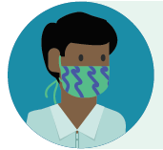
How cloth face coverings work

Cloth face coverings prevent the person wearing the mask from spreading respiratory droplets when talking, sneezing, or coughing. They also prevent you from touching your face unnecessarily.

Face masks are a complementary measure and not a replacement for established preventive practices, such as physical distancing, cough and sneeze etiquette, hand hygiene and avoiding face touching.

If everyone wears a cloth face covering when going out in public the risk of exposure to SARS-CoV-2 can be reduced for the community. You must wear a cloth face mask or homemade item that covers your nose and mouth:

- in every public place
- in the workplace
- at clients and when carrying out visits or deliveries
- when using public transport.

Because people can spread the virus before symptoms start wearing a cloth face covering can protect others around you. Face coverings worn by others protect you from getting the virus from them.

How cloth face coverings are different from other types of masks

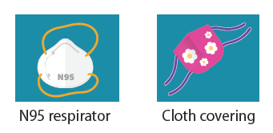
Cloth face coverings are NOT the same as the medical facemasks, surgical masks, or respirators (such as N95 respirators) worn by healthcare personnel, first responders, and workers in other industries.

USING AND LOOKING AFTER YOUR FACEMASKS

You will be given 2 facemasks. Masks must be worn at all times when you are at work. It is very important that cloth masks are used correctly. Incorrect use might result in you putting yourself at risk of spreading Covid-19.

This document describes the procedure to be followed in respect of wearing approved facemasks at work, and in public places. You are responsible for caring for your masks and making sure you wear them properly. Do not share your masks!

Masks

Only use a mask that has been washed and ironed.

Before putting on your mask, always ensure your hands are properly clean by using an alcohol-based sanitizer or washing your hands for 20 seconds using soap and water.
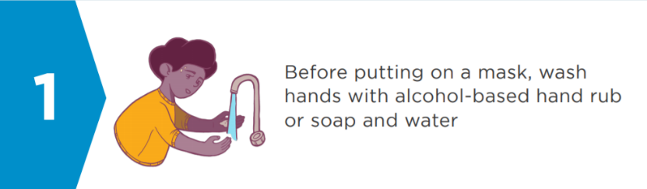
Place the mask with the correct side facing your face and ensure that it covers both your nose and mouth properly.

Tie the strings behind your head, or if you are using elastic bands, make sure these are tight.

Make sure it fits well. It must properly to cover your mouth and nose, also be sure that no open gaps are present where the mask meets your face. Move it around to get the best fit. Do not touch the cloth part.

MAKE SURE YOU CAN BREATHE PROPERLY AND COMFORTABLY.

• Your mouth and nose must be fully covered
• The covering must fit snugly against the sides of your face so there are no gaps
CHECK THAT THE MASK DOES NOT IRRITATE YOUR SKIN.
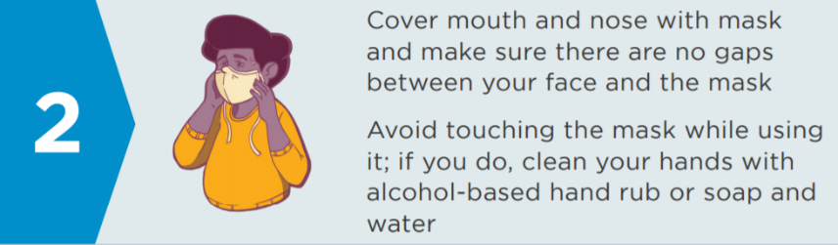
Avoid touching the mask while using it. If you are going to touch the mask, clean and sanitize your hands before touching the mask, as well as after.

Once you have put on the mask, DO NOT TOUCH YOUR FACE again until you take it off.

Face-masks must not be lowered when speaking, coughing or sneezing.
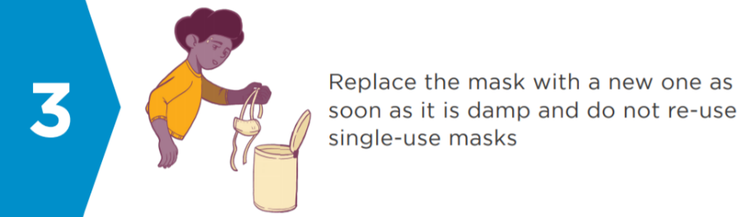

When you take your mask off, undo the ties, and carefully fold the mask inside out, hold it by the strings/elastic and place the mask in a container reserved for washing the cloth mask.

Wash your hands thoroughly and dry before doing anything else.

Cleaning cloth masks

Cloth face coverings should be washed regularly (daily and whenever soiled) using soap and hot water, rinse thoroughly and iron when dry. If you can’t iron the mask, soak it in boiling water for 5 minutes after washing it. Store in a clean container or bag.

Training videos

The following videos are useful to watch:
- Mask Wearing 101: How to Properly Use & Re-use a Mask 5 minutes 03 seconds
https://youtu.be/JwPWdkbyizw
- How to stop glasses steaming up whilst wearing a face mask – 5 minutes 42 seconds
https://youtu.be/LlO4S2iRDD0
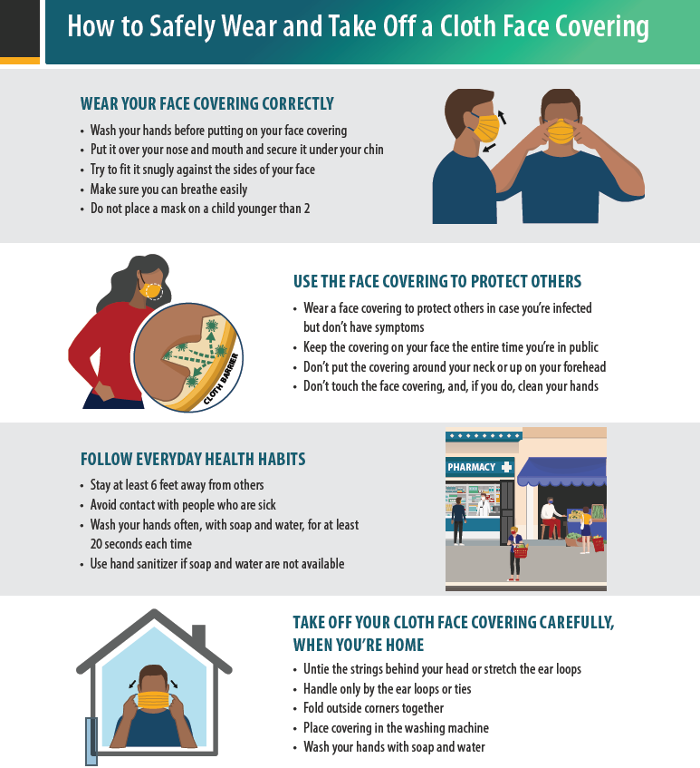

USING DISPOSABLE GLOVES SAFELY PROCEDURE

This document describes the process to be followed when using disposable gloves.

Background

When working with chemicals, cleaning fluids or other substances, it is important that any contaminant on the outer surface of the glove is not transferred onto the skin or other ‘clean’ objects including other items of PPE. The skin is the largest organ of the body and it is important to safeguard it. If the correct procedure is not followed skin irritation as well as cross-contamination can result.

Procedure

PUTTING GLOVES ON

- Gloves must be the correct size, clean and undamaged.
- Make sure you are using a clean surface
- Remove all watches, rings, and other jewellery before putting on your gloves. This helps prevent any accidental rips or tears
- Wash and properly dry your hands
- Insert hands into gloves, making sure that you properly insert all fingers, without damaging the gloves.
- Do not touch your face, mouth or nose, or any unprotected skin with your hands once your gloves are on

REMOVING GLOVES

The most important thing to remember when removing your gloves is to not touch the outside of the glove because then you could get unwanted liquids or substances on your skin.
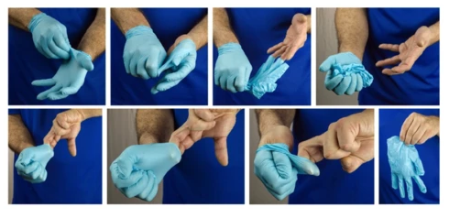

- Wash your hands in the gloves with soap and water
- Pinch and hold the outside of your glove near the wrist area
- Peel downwards, away from the wrist, turning the glove inside out.
- Pull the glove away until it is removed from the hand and hold the inside-out glove with the gloved hand.
- With your un-gloved hand, slide your finger/s under the wrist of the remaining glove, taking care not to touch the outside of the glove.
- Peel downwards, away from the wrist, turning the glove inside out.
- Continue to pull the glove down and over the inside-out glove being held in your gloved hand.

This will ensure that both gloves are inside out, one glove enveloped inside the other, with no contaminant on the bare hands.

PERSON WHO PRESENTS COVID-19 SYMPTOMS AT WORKPLACE PROCEDURE

This document provides the procedures to be followed in the event a person presenting COVID-19 symptoms at the workplace

The purpose is to:

- Identify and diagnose workers at risk of COVID-19 infection at an early stage
- Refer these workers for appropriate treatment, care and timeous return to work
- Protect other unaffected workers, visitors, customers and the general public

Prompt identification and isolation of potentially infectious individuals is a critical step in protecting everyone at the workplace.

Procedure

Any person presenting COVID-19 symptoms before entering the workplace will not be allowed to enter and must go home and continue monitoring themselves.

Separation

Anyone presenting symptoms at work must be kept separate from other persons until they are able to leave for home or testing which should occur as soon as possible.

Facemask

Staff who feel unwell or exhibit COVID-19 symptoms at the workplace must be provided with an FFP1 surgical mask and isolated in a designated room or area.

Face masks must be worn by ill employees and customers to contain respiratory secretions until they are able leave the workplace (that is, for medical evaluation/care or to return home). In the event of a shortage of masks, a reusable face shield that can be decontaminated may be an acceptable method of protecting against droplet transmission.

Temperature

Where a staff member has a high temperature only, but no other symptoms, the person should be re-tested to see if this is still high. If this is the case, continue with the process below. If the person’s temperature has returned to normal, he or she may be permitted to go back to work, but the person should continue to be tested every 4 hours for the balance of the day.

Emergency services

If it is an emergency (if they are seriously ill or injured or their life is at risk) then you should call emergency services and explain the situation and relevant information, such as current symptoms. The public health service must be contacted for advice if necessary.
Emergency services: …………………………….
Public Health Service: ………………………….

Whilst waiting for advice from the designated public health or emergency service, the affected person should remain at least two metres from other people. If possible, find a room or area where they can be isolated behind a closed door, such as a staff office. The number of people entering the isolation area must be restricted.

If possible open a window for ventilation.

They should avoid touching people, surfaces and objects and should cover their mouth and nose with a disposable tissue when they cough or sneeze and put the tissue in a bag or pocket then throw the tissue in the bin. If they do not have any tissues available, they should cough and sneeze into the crook of their elbow.

If they need to go to the bathroom whilst waiting for medical assistance, they should use a separate bathroom if available.

Transporting the person for Testing

Arrangements must be made for the person to be referred to or transported to the closest testing station.

The closest testing site is:

NAME
ADDRESS

Where the person must be transported to the nearest centre for testing, precautions must be taken to ensure that there is no contamination during the transportation. The person should be seated in the back seat with the window open if possible and keep as far away as possible from the driver. Arrangements must be made for the person to go home after testing if this is required.

The vehicle must be properly sanitised afterwards.

Results

On receiving their results the employee and/or health professional supporting the employee should notify their workplace so that the employee is managed accordingly. The workplace should proactively take steps to obtain this information to avoid any delays in reporting.

The worker must follow any oral or written instruction given by a medical practitioner or person authorised by him, nurse or enforcement officer to:

- Go to or be taken to a health establishment or place to be quarantined
- Quarantine him or herself

Pending the final determination of his or her status.

No-one may refuse to be medically examined or tested, admitted to a health establishment, quarantine or isolation, or mandatory prophylaxis or treatment which is required to prevent transmission. An enforcement officer is authorised to issue an instruction or order in this regard.

Where a person does not comply with such instruction, he or she will be placed in quarantine for up to 48 hours pending a court order. The enforcement officer will apply for the order.

Workplace Hygiene

The risk of transmission must be assessed. Their workstation(s) and/or workplace/tools that they were using as part of their job must be cleaned and disinfected.

Workers who may be at risk must be sent for screening and any other appropriate measure to prevent possible transmission.

Leave

Staff who are sick or have symptoms associated with the COVID–19 may not come to work and must take paid sick leave in terms of section 22 of the BCEA.

Each permanent employee is entitled to a “sick leave cycle” for every 36 months’ employment with the same employer. During every sick leave cycle, an employee is entitled to an amount of paid sick leave equal to the number of days the employee would normally work during a period of six weeks. Usually (for an employee who works 5 days a week), this equates to 30 days’ sick leave per 36 months of employment.

The Employee must produce a medical certificate as per the BCEA rules and can send a copy via email or their mobile phones to keep in line with limited to no physical contact. The medical certificate must be issued and signed by a medical practitioner or any other person who is certified to diagnose and treat patients and who is registered with a professional council.

The business is not required to pay employees for sick leave taken when the sick leave entitlement has been exhausted, however authorised unpaid leave can be considered.

Where sick leave has been exhausted, the H&S directive makes allowance for employees to be paid ‘illness benefits’ in terms of the COVID-19 TERS directive. An application must be made for an illness benefit in terms of clause 4 of the Directive issued on 25 March 2020 on the COVID-19 Temporary Employer Relief Scheme.

The COVID-19 TERS directive provides illness benefits initially intended for a 14-day period of agreed self-quarantine as a precautionary measure. This includes situations where an employee is asymptomatic. No medical certificate is needed for the first 14 days but the employer and employee have to submit a letter of proof that they have agreed to “special leave”. In addition to the letter referred to above, there is certain other documentation that has to be submitted (See “UIF Easy-Aid Guide”).

The COVID-19 TERS directive further allows for the 14-day quarantine period to be extended, provided that a medical certificate and ‘a continuation form for payment’ are submitted to the UIF.

PERSON WHO TESTS COVID-19 POSITIVE AT THE WORKPLACE PROCEDURE

If someone tests positive for COVID-19 at work, the following is the procedure to be followed:

Procedure

Any person who is diagnosed as COVID-19 positive may not come to work. He or she must immediately notify their manager and the designated public health services for further advice.

The designated public health services will be in contact with the affected person directly to advise on isolation and identifying other contacts to whom they will give appropriate advice.

The person must not come into contact with other employees or any client or any person who may visit the client premises, to ensure that the immediate risk of the spread of the virus is minimised. He or she must be isolated and/or placed in quarantine as per the requirement in terms of relevant Government Regulations.

In all such instances this must be reported immediately as follows to all of the channels:

- …………….. must be informed and the incident logged.
- …………….. must immediately inform ……………………..

The matter must immediately be reported to the Department of Health and the Department of Employment and Labour so that contact tracing can happen within 24 hours
Department of Health: 0800 029 999
Department of Employment and Labour: ………………………….

An investigation into whether the employee contracted the virus outside the workplace or as a result of work activities or during the performance of work activities will be required.

Investigate the cause including any control failure and review the workplace risk assessment to ensure that the necessary controls and PPE requirements are in place

Contact details

The latest contact details of the employee and any alternative contact details must be available and on record.

At the Workplace:

All staff must give full support to any contact-tracing measures implemented by the Department of Health

A decision must be made as to whether it will be necessary to close the workplace or not.

Key decision makers who will decide if the business has to close:

Responsible for dealing with the media:
(A holding statement to send to media should the business be exposed to COVID-19 can be drafted in anticipation of this)

A positive COVID-19 test in an employee will require all potential contacts in the workplace to be assessed. A thorough investigation must be conducted to identify other employees, client employees or individuals visiting a client site that came within a 2 metres (radius) 2 metres with the positively tested employee.

This includes:

- any worker that has been in close face-to-face or touching contact
- anyone who has spent any length of time with the worker while he or she was symptomatic
- anyone who has cleaned up any bodily fluids
- close friendship groups or workgroups
- any worker living in the same household as a confirmed case

If a worker is confirmed to have COVID-19, …………………………… will inform fellow workers of their possible exposure to COVID-19 in the workplace but ensure that strict confidentiality is maintained. How staff will be notified:

Workers who may be at risk must be sent for screening and any other appropriate measure to prevent possible transmission. The “Procedure for when a staff member has come into contact with a COVID-19 positive person at the workplace” must be followed.

Employee works at client site

If the employee that tested positive worked at a client site the client must be informed about the positive test to ensure that appropriate action. In such a case, ……………….. will co-ordinate interaction with the client.

Workplace Hygiene

The workplace must be thoroughly cleaned and sanitised according to the procedure for cleaning workplace where there has been a positive COVID-19 case.

Staff returning to work

You will only be allowed to return to work if you have a valid medical certificate stating when you may return to work and/or if you underwent a mandatory required quarantine or isolation period prescribed in a Government Regulation or by a medical practitioner.

If you return to work after isolation or quarantine period, you must follow general work restrictions that include:

- wearing a surgical mask at all times while at work for a period of 21 days from the initial test
- implement social distancing measures as appropriate
- adherence to hand hygiene, respiratory hygiene, and cough etiquette
- continued self-monitoring for symptoms, and seek medical re-evaluation if respiratory symptoms recur or worsen

The post quarantine symptom screening register must be completed and checked for any additional symptoms.

Privacy and stigma

It is important to address these issues with sensitivity and to respect workers’ privacy and confidentiality. Be aware of the risk that workers who have been ill with COVID-19 may suffer stigma and discrimination and this must be properly managed.

Leave

If you are sick or have symptoms associated with the COVID–19 you may not come to work and must take paid sick leave in terms of section 22 of the BCEA.

Each permanent employee is entitled to a “sick leave cycle” for every 36 months’ employment with the same employer. During every sick leave cycle, you are entitled to an amount of paid sick leave equal to the number of days you would normally work during a period of six weeks. Usually (for an employee who works 5 days a week), this is 30 days’ sick leave per 36 months of employment.
You must produce a medical certificate as per the BCEA rules and can send a copy via email or your mobile phones to keep in line with limited to no physical contact.

The medical certificate must be issued and signed by a medical practitioner or any other person who is certified to diagnose and treat patients and who is registered with a professional council.

Where sick leave has been exhausted, the H&S directive makes allowance for you to be paid ‘illness benefits’ in terms of the COVID-19 TERS directive. An application will be made for an illness benefit for you and will be paid to you once received.

COIDA and sick leave

Covid-19 has been declared an occupational disease. If you are contract the virus at work then the application will be made to claim compensation in terms of the Compensation for Occupational Injuries and Diseases Act, 1993 (COIDA).

PROCEDURE FOR WHEN A STAFF MEMBER HAS COME INTO CONTACT WITH A COVID-19 POSITIVE PERSON AT THE WORKPLACE

If someone has been confirmed COVID-19 positive, the procedure for staff who are COVID-19 positive must be followed. Workers exposed to a co-worker with confirmed COVID-19 must be given instructions on what to do according to company policies and the national authorities´ guidance.

Definitions

High risk, confirmed COVID-19 exposure, asymptomatic:
Close contact within 1 metre of a COVID-19 confirmed case for >15 minutes without PPE (no face cover/eye cover) or with failure of PPE and/or direct contact with respiratory secretions of confirmed COVID-19 case (clinical or laboratory).

Low risk, suspected COVID-19 exposure, asymptomatic:
>1 metre away from a COVID-19 confirmed case for <15 minutes OR within 1 meter but wearing PPE (face cover, eye cover). Also consider lower risk if COVID case was wearing a surgical mask (source control).

Procedure
Management must find out whether any staff member:

- Has had face to face contact with the infected person (within 1 meter)
- Was exposed to any bodily fluids of the person, and if so, what and where
- Had direct contact with the environment where the confirmed COVID-19 person was touching or in contact with
- What personal protection equipment was being worn
- Whether the removal and replacement of PPE was done according to protocol
- Whether hand hygiene was done after touching the person’s surroundings or cleaning
- Whether high touch surfaces and other areas that the person was in, was being cleaned and sanitised regularly

The line manager must assess and confirm COVID-19 exposure risk (if uncertain, refer to WHO tool for assessing exposure risk).

Low risk, suspected COVID-19 exposure, asymptomatic:

For low-risk exposures to a confirmed COVID-19 positive case, workers can continue to work with self-monitoring (twice daily temperature an daily symptom check) for 14 days after last COVID-19 exposure. (use symptom monitoring form below)

High risk, confirmed COVID-19 exposure, asymptomatic:

Notify exposure to NICD.

Staff member must perform daily symptom self-check and complete the symptom monitoring form until 14 days since last COVID-19 exposure. Exposure to other persons in the household should be limited and PPE and hygiene measures must be maintained.

Identify persons who have conditions that put them at higher risk of serious illness (older people (>60 years) and those with chronic conditions (including hypertension, lung or heart problems, diabetes, or who are undergoing cancer treatment or some other immunosuppression) and pregnant workers) and advise them to take additional precautions.

If the person is asymptomatic through day 7, consider for return to work, following a negative RT-PCR on day 8.

If possible COVID-19 symptoms develop, then the procedure for workers who show COVID-19 symptoms must be followed

At the Workplace

- Assess all potential contacts in the workplace
- inform the Department of Health and the Department of Employment and Labour
- Investigate the cause including any control failure and review the workplace risk assessment to ensure that the necessary controls and PPE requirements are in place
- give administrative support to any contact-tracing measures implemented by the Department of Health

The management team of the office or workplace will be contacted by the designated public health services to discuss the case, to identify people who have been in contact with them and to advise on any actions or precautions that should be taken.

A risk assessment of each situation will be undertaken by the designated public health services with the lead responsible person in your workplace. They will provide advice on how to manage staff and members of the public, based on their assessment of the risk. The designated public health services will provide advice to:

- any worker that has been in close face-to-face or touching contact
- anyone who has spent any length of time with the worker while he or she was symptomatic
- anyone who has cleaned up any bodily fluids
- close friendship groups or workgroups
- any worker living in the same household as a confirmed case

Staff who have not had close contact with the original confirmed case may not need to take any precautions other than monitoring their health for symptoms and can continue to attend work.

The designated public health services will also be in contact with the affected person directly to advise on isolation and identifying other contacts to whom they will give appropriate advice.

WHAT TO DO IF YOU HAVE BEEN IN CLOSE CONTACT WITH A PERSON WITH CONFIRMED DISEASE AND ARE ASKED TO HOME QUARANTINE
https://www.nicd.ac.za/what-to-do-if-i-am-a-close-contact-of-a-person-with-confirmed-disease-and-am-asked-to-home-quarantine/

This advice is for people who are close contacts of a person with confirmed coronavirus disease (COVID-19), do not have any symptoms and have been asked to quarantine at home. This guidance does not apply to people who have been asked to quarantine in a designated facility.

What does being a close contact mean?

You have been in close contact with someone who has confirmed coronavirus disease, but you do not have any symptoms yourself. Close contact means that you:

- had face-to-face contact within 1 meter or
- were in a closed space for more than 15 minutes with a person with COVID-19.

This contact happened while the person with COVID-19 was still “infectious”, i.e. from 2 days before to 14 days after their symptoms began. For example, you may be someone who:

- Lives in the same household as a person with COVID-19
- Works closely in the same environment as a person with COVID-19
- Sat in the same classroom as a person with COVID-19
- Attended the same gathering as a person with COVID-19
- Provided direct care for a person with COVID-19 in a healthcare setting without using the proper personal protective equipment
- Sat within two seats (1 meter) in any direction of a person with COVID-19 case in any kind of vehicle including buses, minibus taxis, etc.

Who will be in touch with you from the government or national institute for communicable diseases (nicd)?

The person with COVID-19, with whom you were in close contact, made a list of all the people he/ she had close contact with from 2 days before they became ill.

You may therefore be called, visited at home or advised by government officials, community health workers and/or the NICD.

The purpose of this contact is to assist you to self-quarantine at home for 14 days after your last contact and to monitor you for symptoms. The number of times you are contacted by government officials or the NICD is subject to change.

Why have you been asked to quarantine at home?

You have been exposed to a person with COVID-19 while they were still able to transmit infection. It is therefore possible that you have been infected with the new coronavirus (SARS-CoV-2).

Staying at home in quarantine will help to control the possible spread of the virus to your friends, relatives and your wider community. In particular, staying at home will help prevent possible spread to the most vulnerable people in our communities, who are risk for severe illness.

The coronavirus is spread by droplets. When an infected person coughs, exhales or sneezes, they release droplets of fluid containing virus particles into the air. Other people can become infected by breathing in these droplets if they are standing within a few meters from the infected person.

The larger droplets can also fall on nearby surfaces and objects. The virus can survive on hard surfaces (plastic and stainless steel, for example) for up to 72 hours. Other people can become infected when they touch contaminated surface, then touch their eyes, nose or mouth. People cannot be infected through the skin.

If you understand how coronavirus disease spreads, this will help you to understand how to prevent spreading the infection to others. Stay a few meters away from other people, and at frequent intervals wash your hands with soap and water for at least 20 seconds or sanitise your hands using an alcohol-based hand sanitizer.

What does home quarantine mean for you?

STAY AT HOME.

- Do not go to work, school, or any public areas. If necessary, talk to your employer and let them know that you cannot come to work.
- Do not use any public transport (including buses, minibus taxis and taxi cabs).
- Do not travel.
- You should cancel all your routine medical and dental appointments.
- If possible, you should not even go out to buy food, medicines or other essentials. You should ask friends or relatives to help you to buy groceries and essentials.

If you have access to the internet, you can order your shopping or medications online but tell delivery drivers to leave any items for collection outside your house. Delivery drivers should not come into your house at all.

- You should not go outside to exercise, unless you can maintain a safe distance from others in an outdoors space.
- You should not have any visitors in your home during your quarantine period.

Keep in touch with your relatives, friends and colleagues over the phone, internet or by using social media.

How long will you need to quarantine at home?

You can end your home quarantine 14 days after your last contact with a person with COVID-19. No laboratory tests will be done at any time during your home quarantine period, unless you develop symptoms.

What symptoms do I need to monitor for during my home quarantine?

If you develop a fever, cough, shortness of breath, sore throat, muscle aches or other flu-like symptoms from 2 to 14 days after your close contact with a person with COVID-19, you should immediately contact your healthcare provider.

If you become ill, you should cover your mouth and nose if you sneeze or cough with disposable face tissue or into your elbow. Dispose of tissues then immediately wash your hands.

Wash your hands regularly using soap and water for at least 20 seconds or use alcohol-based hand sanitizers (containing at least 60% alcohol).

Refer to guidance on what to do if I think I have coronavirus disease.

What does home quarantine mean for other people who live in your household?

If you live with other people, as far as possible, you should stay in a separate room and away from other people in your household. If a separate room is not possible, try to keep to one area of your home, at least 2 meters (3 steps) away from other people.

Limit contact with any pets and animals.

Wash your hands regularly using soap and water for at least 20 seconds or use alcohol-based hand sanitizers (containing at least 60% alcohol).

If possible, use a separate bathroom. If you have to share a bathroom, clean the bathroom after every use. If you share a kitchen, avoid using the kitchen at the same time as other people. If possible, have your meals in your separate room/ area and use separate utensils.

Do other members of your household need to stay at home during your quarantine period?

If you live with other people, and you are able to stay physically apart from them, they can continue their usual activities outside the home. If you are unable to stay apart from members of your household, they should also quarantine for the same period.

What do you do if you live with children?

If you live with children, you should keep following this advice to the best of your ability. However, we understand that this advice will be difficult to follow with younger children.

Will you be tested for coronavirus disease as a close contact?

You will only have a laboratory test performed if you develop symptoms within 14 days of your last close contact with a person with COVID-19 who is considered infectious, i.e. able to transmit infection. A person with COVID-19 is considered infectious from 2 days before to 14 days after they became ill.

Refer to guidance on what to do if I think I have coronavirus disease?

Will your own close contacts be tested for coronavirus disease?

No, your close contacts will only have laboratory testing if you are first confirmed to have COVID-19 and they develop symptoms. Refer to guidance on what to do if I think I have coronavirus disease?

HYGIENE FOR OFFICES AND PUBLIC SPACES WHERE THERE ARE SUSPECTED OR CONFIRMED CASES OF COVID-19

*HIGH RISK

Coronavirus symptoms are similar to a flu-like illness and include dry cough, sore throat, fever, tiredness or shortness of breath. Once symptomatic, a person is a high risk in terms of contagion. It is therefore vital that the correct risk mitigation measure be implemented to reduce the risk of contagion.

This documents the procedure to be followed to clean and disinfect rooms or areas occupied by those with suspected or with confirmed COVID-19. It is aimed at limiting the survival of SARS-CoV-2 in key environments.

Advice on cleaning must be obtained from designated public health services where there are suspected or confirmed cases of COVID-19.

Personal protective equipment must be used and procedures must be properly and strictly followed. Failure to follow proper procedure places everyone at risk of viral infection and will result in disciplinary action with possible termination of employment.

Closing of workplaces

Whether you need to suspend operations in your workplace will depend on factors such as the size of the workplace, nature of work, number of people, and suspected areas of contamination in your workplace.

There is no need to close down an entire workplace, while cleaning and disinfection takes place, if the person infected, or suspected to be infected, has only visited parts of the workplace which can be closed off.

Decisions to close the workplace or not must be made after assessing the risks to staff, visitors and the general public. All decisions made must be documented with full reasons and be approved by the governing body.
THOROUGH CLEANING AND DISINFECTION MUST OCCUR BEFORE ANY WORKERS RETURN TO AFFECTED AREAS.

- Cleaning removes dirt and impurities, including germs, from surfaces. Cleaning alone does not kill germs. By removing germs, it decreases their number and the risk of spreading infection.
- Disinfecting works by using specific chemicals to kill germs on surfaces. It does not necessarily clean dirty surfaces or remove dead germs. Disinfecting should happen after cleaning to reduce the risk of spreading infection.
- Sanitizing also kills germs, but disinfecting kill more of them. Some products are capable of doing both, but disinfecting requires a bit more work. Still, sanitizers effectively lower the risk of infection.

If it has been more than 7 days since the person with suspected/confirmed COVID-19 visited or used the facility, enhanced cleaning and disinfection is not necessary.

Covid-19 symptom monitoring

Staff and workers performing cleaning, laundry, and trash pick-up activities must be closely monitored for any symptoms of COVID-19

Provide instructions on what to do if they develop symptoms within 14 days after their last possible exposure to the virus.

At a minimum, any staff should immediately notify their supervisor and the COVID-hotline if they develop symptoms of COVID-19.

Health and safety

Ensure you are trained on the hazards of the cleaning chemicals used in the workplace.

Cleaning staff must be trained on properly using Personal Protective Equipment (PPE) before any cleaning tasks. Training should include when to use PPE, what PPE is necessary, how to properly don (put on), use, and doff (take off) PPE, and how to properly dispose of PPE.

Read the product label and Safety Data Sheet for the cleaning product(s) before using and make sure you follow all instructions, including all required personal protective equipment (PPE).

Make sure the product is suitable for use on the surface you are cleaning.
Read instructions in case of chemical hazard, what to do in the event of skin contact etc. and make sure that there is a first aid kit with eye wash and whatever is needed to treat accidents with cleaning chemicals.

DO NOT HAVE YOUR CELLPHONE OR ANY OTHER ITEM WITH YOU WHICH YOU MIGHT ACCIDENTALLY TOUCH WHILE YOU ARE CLEANING.

Personal protective equipment (“ppe”)

All cleaners of an area of suspected contamination must be equipped with appropriate Personal protective equipment (PPE).

This includes:

- Heavy duty disposable gloves
- safety eyewear to protect against chemical splashes
- a disposable apron or other protective covering. If gowns are not available, coveralls, aprons or work uniforms can be worn during cleaning and disinfecting.

Cleaning staff should wear disposable gloves and gowns for all tasks in the cleaning process, including handling trash.

PPE must be checked to ensure it is in good condition and not damaged. Cleaning staff should immediately report breaches in PPE such as a tear in gloves or any other potential exposures to their supervisor.

Gloves and gowns should be compatible with the disinfectant products being used.

Before putting on PPE:

Wash your hands using soap and water for at least 20 seconds, or where this is not possible, use hand sanitiser of with at least 60% ethanol or 70% isopropanol as the active ingredient before putting on, and after removing PPE.

Once PPE is put on:

- Do not touch your face, nose or mouth
- Do not touch the front of the mask – see procedure on using masks
- Do not remove PPE until you are finished

Gloves and gowns should be removed carefully to avoid contamination of the wearer and the surrounding area. When you take off protective equipment, do not to touch their outer surfaces.

Wash hands properly or sanitise immediately after gloves are removed.

Cleaning equipment

Check to see what equipment is needed and make sure you have everything you need. Check that the equipment is clean, in working order and appropriate.

If a person becomes ill in a shared space, these should be cleaned using disposable cloths and the usual detergents, according to current recommended workplace legislation and practice.

- Coverall
- Heavy duty gloves
- Safety goggles
- Protective facemask

- Detergent
- Disinfectant
- Hot water
- Cold water

- Chalk (for marking surfaces and areas which have been sanitised)
- Non-slip ladder
- Extension handles

- Heavy duty plastic rubbish bags

- Broom
- 2 Buckets – 1 for washing, 1 for rinsing
- Mop
- Vacuum, bags, filters
- Brushes
- Dustpan and brush

- Sponges
- Drying towels

- Pressure-washing equipment where necessary
- Chemical disinfection.
- Disinfectants
- Mixing apparatus
- Dispensing equipment
- Containment system for concentrated disinfectants
- Containers and other equipment to collect and properly dispose of used disinfectant

Separate equipment such as mops, brooms, cloths to prevent cross contamination. Equipment can be color-coded or marked to identify the proper equipment for designated areas.

Procedure

If the person with suspected or confirmed COVID-19 is in the area which must be cleaned:
The person must be removed from the area, and the correct procedure of dealing with persons who are infected or suspected to be infected with the virus must be followed.

If other persons are in the area which must be cleaned:
Remove all persons from the area and follow the correct procedure.

Step 1:
Identify all areas visited by the ill or suspected ill person and ensure these are properly closed off. No persons other than properly protected cleaning and other authorised staff are permitted in the area.

Open outside doors and windows and use ventilating fans to increase air circulation in the area.
Wait 24 hours or as long as practical before beginning cleaning and disinfection.

Step 2:
All waste that has been in contact with the individual, including used tissues, and masks if used, should be put in a plastic rubbish bag and tied when full. The plastic bag should then be placed in a second bin bag and tied.

It should be put in a safe place and marked for storage until the result is available. If the individual tests negative, this can be put in the normal waste.

Step 3:
All surfaces and areas that the person may have come into contact with must be cleaned properly and then disinfected. Public areas where a symptomatic individual has passed through and spent minimal time in (such as corridors) but which are not visibly contaminated with body fluids must be properly cleaned and disinfected.

Clean and disinfect areas such as offices, bathrooms, common areas, kitchen, canteen, etc. Clean and disinfect all potentially contaminated high-contact areas such as:

- Desks
- Tables
- Chairs
- Keys
- Doorknobs
- Light switches
- Countertops
- Handles
- Phones
- Computers
- Tablets
- Touch screens
- Keyboards
- Toilets

- Taps
- Sinks
- Shared electronic equipment (like, remote controls, and ATM machines)

- Time clocks
- Electrical panels
FOCUS ON ONE AREA AT A TIME AND ENSURE THIS IS PROPERLY CLEANED AND THEN SANITISED BEFORE MOVING ON TO THE NEXT AREA.

Cleaning:

Follow the correct cleaning procedure dependent on the surface

Start with the dirtiest area and clean all surfaces and objects which are visibly contaminated with body fluids.

Ventilation
Individually clean (wash) and sanitise fans and louvers on windows, and air conditioners

Soft (Porous) Surfaces
For soft (porous) surfaces such as carpeted floor, rugs, and drapes, remove visible contamination if present and clean with appropriate cleaners indicated for use on these surfaces.

After cleaning: If the items can be laundered, launder items in accordance with the manufacturer’s instructions using the warmest appropriate water setting for the items and then dry items completely.

Hard (Non-porous) Surfaces
If surfaces are dirty, they should be cleaned using a detergent or soap and water prior to disinfection. Use the correct detergent (soap) and water. Use warm to hot water (90–130°F [32–54°C] or higher).

Use clean, cold water to rinse all contaminated surfaces to remove any remaining dirt, debris, and residue. This is necessary to remove any soap or detergent residue, which may inactivate disinfectants.

Dry all washed areas or allow enough drying time so that no free liquids remain on the washed surfaces.

Electronics
For electronics such as tablets, touch screens, keyboards, remote controls, and ATM machines, remove visible contamination if present.

Follow the manufacturer’s instructions for all cleaning products.
Consider use of wipeable covers for electronics.

MARK ALL CLEANED AREAS WITH CHALK WHEN DONE.

Sanitising:

After each area or item is cleaned, it must be properly sanitised using disinfectant.

Do not use different types of disinfectants together.
Store disinfectants safely and securely, out of direct sunlight and away from heat sources.

Mix disinfectants in a well-ventilated area. Some concentrated products recommend the use of a local exhaust ventilation system. For spraying or misting products, spray directly into the cleaning cloth to dampen the cloth for use. Take care not to generate a mist.

Apply the disinfectant to the contaminated surfaces in accordance with the site-specific plan and product label. Apply disinfectant in a pre-cleaned facility from top to bottom and from back to front.

Ensure that the disinfectant has adequate contact time as specified on the disinfectant label. To work properly, the surface you disinfect must remain wet for a long period of time, between 3 to 5 minutes.

Soft (Porous) Surfaces
Disinfectant is not suitable on fabric surfaces as it only works with extended contact time with the surface.

Hard (Non-porous) Surfaces
For disinfection, most common EPA-registered household disinfectants should be effective. Follow the manufacturer’s instructions for all cleaning and disinfection products for concentration, application method and contact time, etc.

Disinfectants containing ≥ 70% alcohol, quaternary ammonium compounds, chlorine bleach or oxygen bleach are suitable for use on hard surfaces (that is, surfaces where any spilt liquid pools, and does not soak in). These will be labelled as ‘disinfectant’ on the packaging.

CHECK TO ENSURE THE PRODUCT IS NOT PAST ITS EXPIRATION DATE.

Diluted household bleach solutions (at least 1000ppm sodium hypochlorite) can be used if appropriate for the surface. Follow manufacturer’s instructions for application, ensuring a contact time of at least 3 minutes, and allowing proper ventilation during and after application.

NEVER MIX HOUSEHOLD BLEACH WITH AMMONIA OR ANY OTHER CLEANSER.

Electronics
Follow the manufacturer’s instructions for disinfection products. If no manufacturer guidance is available, consider the use of alcohol-based wipes or sprays containing at least 70% alcohol to disinfect touch screens. Dry surfaces thoroughly to avoid pooling of liquids.

Consider use of wipeable covers for electronics.

Linens, Clothing, and Other Items That Go in the Laundry
In order to minimize the possibility of dispersing virus through the air, do not shake dirty laundry.

Wash items as appropriate in accordance with the manufacturer’s instructions. If possible, launder items using the warmest appropriate water setting for the items and dry items completely. Dirty laundry that has been in contact with an ill person can be washed with other people’s items.

Clean and disinfect hampers or other carts for transporting laundry according to guidance above for hard or soft surfaces.

MARK ALL SANITISED AREAS WITH A DIFFERENT COLOUR CHALK WHEN DONE

Outdoor areas

Cleaning and disinfection of wooden surfaces (play structures, benches, tables) or groundcovers (mulch, sand) is not recommended.

Pavement and roads should not be disinfected. Spread of COVID-19 from these surfaces is very low and disinfection is not effective.

HANDS MUST BE REGULARLY CLEANED

Follow normal preventive actions including cleaning hands and avoiding touching eyes, nose, or mouth with unwashed hands.

If soap and water are not available and hands are not visibly dirty, an alcohol-based hand sanitizer that contains at least 70% alcohol may be used. However, if hands are visibly dirty, always wash hands with soap and water.

Disposal or cleaning of materials and ppe

Once cleaning and disinfection is complete, place disposable cloths, PPE and covers in a plastic rubbish bag and tie at the top.

Place tied bag inside another rubbish bag (double-bagging), tie at the top and dispose of the bag in the allocated disposal area ready for washing.

Wear disposable gloves to handle used cloths, PPE and covers. Wash your hands thoroughly with soap and water for at least 20 seconds after removing the gloves.

Reusable, non-washable PPE such as eye protection, must be wiped clean with a detergent solution first, then wiped over with a disinfectant, and left to air dry. Smearing or residues might result, and this can be cleaned off by using more detergent solution and rinsing clean only after the disinfectant has dried.

Reusable (washable) clothing must be washed in a regular cycle wash using the warmest possible setting with normal washing detergent. DO NOT shake out the items before placing in the washing machine. Clean hands after handling dirty laundry.

Regularly wash the hamper in which used PPE is stored while it is waiting to be laundered. If the hamper is not washable, use a disposable lining, and replace regularly.

Cleaning equipment including mop heads and cloths should be laundered using hot water and completely dried before re-use. Cleaning equipment such as buckets should be emptied and cleaned with a new batch of disinfectant and allowed to dry completely before re-use.

Post-cleaning inspection

After cleaning and disinfecting, an inspection must be done to ensure that appropriate disinfection has been completed successfully. If there is any doubt or sign of inadequate procedures, additional measures may be required.

The evaluation must assess and confirm that:

- Staff used the correct equipment and materials
- Staff properly used PPE
- All contaminated areas have been identified and properly disinfected with an
- appropriate disinfectant.
- Any contaminated wood or items difficult to disinfect have been appraised, removed, and
- disposed of in a manner that minimizes spread of pathogens (e.g., burned, composted, or
- buried)
- All infected or suspected areas have been properly cleaned and disinfected.
- All fixtures and fittings have been properly cleaned and disinfected.
- Cleaning materials and disinfectant were correctly diluted to the correct concentration.
- The necessary contact time of the disinfectant was permitted.
- Effluent from the disinfection procedures has been properly disposed of

REMEMBER
- Wear a face mask at all times. Wear it properly, and only touch it when necessary and with clean hands.
- Sanitise or wash your hands regularly. Wash for at least 20 seconds.
- If you are high-risk individual, and cannot work from home, consider using a full face shield as well as a mask.
- Continue practicing social distancing. When addressing colleagues or advising clients, maintain a safe distance - even when greeting.
- No group meetings with colleagues. If you can maintain the Zoom or MS Teams meeting culture, opt for this instead.
- Take heed of any new signage, safety bins and other measures your office has to put into place.
- Remember to keep your desk and office sanitised as necessary, as well, in between. Maintain a clean desk policy with no unnecessary papers and surfaces to touch. Don't forget to sanitise your laptop and other IT equipment with the appropriate disinfectant wipes.
- Don't share stationary amongst staff. Also, if your client has to use a pen from your office, make sure you sanitise it before and after they use it.
- Only meet clients by appointment, and only have limited numbers of clients in offices.
- All staff and clients will be screened as they arrive at the office with an infra-red thermometer - each time they enter. Please ensure that clients who come into the office for appointments are aware that there is a screening procedure.
- We would also urge you to stay abreast of Regulations and requirements for your offices, ensuring the safety of yourself and your staff at work and for engaging with clients.

CONFIRMATION OF RECEIPT OF INDUCTION AND TRAINING

I, ………………………………………………………………………………………………….(FULL NAMES)

ID:……………………………………………………………………………………………………………………

Confirm that I have been provided with and have read and understand the contents of this induction manual. I understand that I must strictly comply with all internal rules and procedures and that failing to do so, places my colleagues and the general public at risk of infection, and even death.
If I do not follow the procedures in this manual and in the COVID-19 policies and procedures manual, I will be subject to disciplinary measures up to and including dismissal.
If I have any queries, I will immediately ask my manager.

Signed: ………………………………………………………………………… Date: …………………………..

